「2018全國高中職英語會話競賽」活動簡章
1.活動目的：
本次競賽活動旨在提升學生英語學習興趣與動機，以各項競賽方式來提供學生學習英語文成果發 表與展演、及相互觀摩的機會。活動項目為英語會話競賽，期能達到讓英語生活化，活潑化之學 習目標。
2.主辦單位：大葉大學英語學系

3.贊助單位：雄和教育基金會

4.競賽時間：107 年 12 月 15 日（星期六）上午 09:00~12:00

5.報名方式：

5.1 報名日期：即日起至 107 年12月 07 日（星期五）下午5:00止。
5.2報名方式：請填妥報名表，以 Email 方式報名，主旨請標明「校名--負責老師--2018高
中職英語會話競賽」。
5.3 報名Email信箱: deconf@mail.dyu.edu.tw
5.4活動聯絡人：吳語若小姐
5.5 聯絡電話：04-8511888 # 6011
5.6地址：彰化縣大村鄉學府路 168 號外語大樓
(★備註：Email 報名後，本系會於 3日內以 Email 回覆是否報名成功，若報名 3 日內仍沒有收到Email 回覆者，或若有任何疑問請致電本系查詢。)
(★備註: 本活動預計 30 支隊伍參加，若超過限額，依 Email 報名時間先後決定錄取與否。)

6.競賽地點：大葉大學外語大樓 (Room J107, Room J423 及 Room J412-1)。

7.參加對象：全國高中職學生，不限科別，最多 3 人組成一隊，每校最多 3 隊。

8. 參賽資格: (參賽者需同時符合下列各條件)
(1) 台灣公私立高中職(含五專一年級~三年級)在學學生。
(2) 具有中華民國國籍,且非以英語為母語之在學學生。
(3) 未曾在英語系國家居住超過六個月(含)以上者。
(4) 未曾在英語系國家或英語(含雙語)學校求學(含留學、遊學及交換學生)累計
就讀超過六個月(含)以上者。
(5) 經由各校承辦單位遴選及報名者。
(6) 以校為單位，每校推派人選以不超過3位學生為原則。
(7) 主辦單位得視報名狀況提早結束或延長報名時間。

9.進行方式：
9.1出場順序：參賽者需於當天上午 8:00 至 8:30 在本校外語大樓 Room J107簽到處準時辦理報到，並出示學生證或身分證以便工作人員查驗，再抽出場順序，未準時報到者由主辦單位代抽。未於上台前 6 分鐘內完成報到之參賽者，視為棄權。
9.2競賽活動：此活動包含自選題及大會指定題兩部分。自選題比賽由學生自行設計對話內容，並有 3 分鐘的表演時間。大會指定題由各參賽隊伍分別於自選題表演結束後，立即抽籤，黏貼或夾扣號碼牌後 進入『準備區』準備。
9.3報名隊伍皆須全程參加自選題及大會指定題
a. 參賽隊伍依號次進行 3 分鐘自選題以及3 分鐘大會指定題之英語會話比賽。
b. 選出優勝者 3 隊及優等 7 隊，比賽結果於當天公布並進行頒獎。

10.獎勵方式：
第1名 (1隊): 獎金NT $3,000 + 獎品NT $ 500 + 獎狀
第2名 (1隊): 獎金NT $2,000 + 獎品NT $500 + 獎狀
第3名 (1隊): 獎金NT $1,000 + 獎品NT $500 + 獎狀
優等 (7隊): 每隊獎品NT$500 + 獎狀
參加獎 (所有參加隊伍): 參賽證明
(★備註:本獎金、獎品由雄和基金會提供。)

11.競賽規則請參照下表：
競賽項目 | 英語會話競賽
 | 增強學生英文學習興趣，結合創意及團隊合作等能力；祈使透過
活動目的 | 校際交流機會，激發學生英文口語演說技巧，以培育全方位英語
 | 文達人。
 | 1. 題目：(1)自選題(50%)、(2)大會指定題(50%)
 | 2. 自選題與指定題各別演出時間以 3 分鐘為限。
 | 3. 各隊參賽人員最多 3 名，所有成員均需參與口語演說。
 | 4. 內容由學生自行改編或創作。
競賽規則 | 5. 號碼牌請務必黏貼或別扣在身上顯眼處，遺忘或遺失將予以
 | 扣分。
 | 6. 內容請於 12月 07 日前以電子檔傳至主辦單位，主旨請標明
 | 「校名--負責老師--2018 高中職英語會話競賽」
 | Email: deconf@mail.dyu.edu.tw
 | 評審將以下列各項評判標準，予以給分。
評分標準 | 1. 語言表現：60%（發音20%、語調20%、流暢度20%）  2. 內容：30%（創意15%、結構性15%）
 | 3. 舞台表現：10%（台風5%、團隊表現5%）

2018 全國高中職英語會話競賽報名表
大葉大學英語學系主辦

學校： |  |  | 科別：
指導老師： |  |  | 聯絡電話：
參賽聯絡人姓名：
聯絡電話：(日) (夜) (手機 )
E-mail：
通訊地址：
參加同學姓名 | 班級 | 手機 |  | E-mail
1.
通訊地址：
2.
通訊地址：
3.
通訊地址：
備註：
◎ 請指導老師在簽名前確認已經詳細閱讀參賽簡章並同意簡章上的規定。
◎ 請將報名表寄到deconf@mail.dyu.edu.tw
◎ Email 報名後，本系會回覆是否報名成功；3 日內仍沒有收到 Email 回覆者，
或若有任何疑問，請致電查詢。
◎ 表格若不敷使用，請自行影印使用

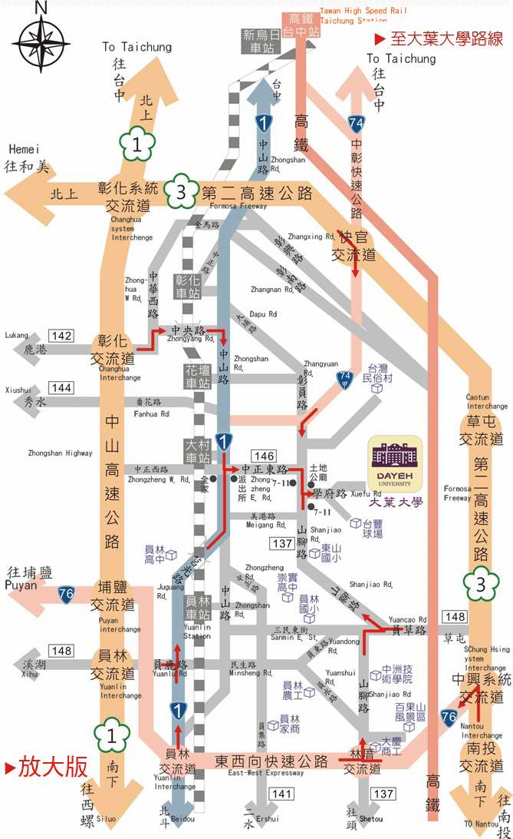
12.本校交通資訊：http://www.dyu.edu.tw/traffic.html?type=0

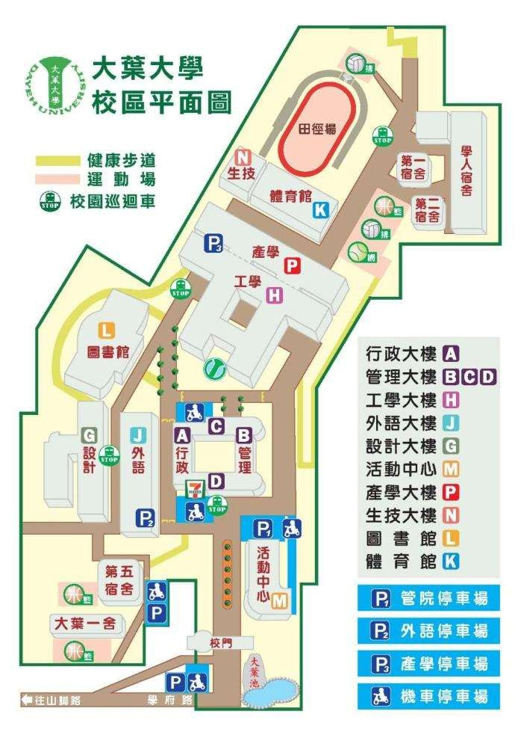
競賽會場 J423 與 J420A-1

觀 光

About the Impromptu Conversation Activity
The second part of the competition is the impromptu conversation activity. The impromptu conversation is like an impromptu speech in that you will be given a topic and 10 minutes of preparation time. However, it differs from an impromptu speech in other ways. First, it involves acting rather than expression of your views on an issue or problem. Second, it will be done in teams instead of individually. Here lies the “conversational” element. During the 10 minute preparation period, you will have enough time to plan what your group will do. However, you will not be able to memorize every word you will say. To make your impromptu conversation a success, you will have to choose many of your words “on the spot” and not ahead of time.

Here are some guidelines for preparing your impromptu conversation.

First, get familiar with the format of the conversation topics. Each topic presents a situation that your group will dramatize. One example topic is given below:

A conversation taking place on the Da-Yeh University campus; please create a conversation in which the judges will know you are on the Da-Yeh University campus.

Remember, the topic will not give you a story plot or particular words to present. Instead, your group will choose lines and actions that bring the situation to life. An example impromptu conversation is given below, on the following page.

Second, act your conversation out instead of just reciting your lines. Your listeners (including the judges) will be seated some distance from your group. You may need to exaggerate your pronunciation and expression to make yourself understood. Miming, body language, and appropriate use of your voice (e.g., pauses and pitch variation) will help the listeners understand what you are saying.

Third, keep it simple. Avoid complicated words: they are hard to pronounce, and many of your listeners may not know them. Remember that perfect grammar and an “advanced” vocabulary are not as important as your ability to dramatize your topic.

Finally, find ways to make your topic fun. Give your characters personality. Let them interact with one another and say funny things so you will keep your listeners’ attention.

To prepare for the impromptu conversation, try practicing the example topics above with your group. If necessary, ask your teacher to create new topic situations for further practice. The more you practice, the more confidence you will gain. With a bit of imagination and some practice, your group will learn to do its best.

Examples for Impromptu Conversation
Example Topic: A conversation taking place on the Da-Yeh University campus; please create a conversation in which the judges will know you are on the Da-Yeh University campus.

The group consists of three people, A, B, and C. They start the conversation by miming their actions. They are in a car together on the way to DYU, with A in the driver’s seat.

A: Well, it looks like we are finally here. This is the main gate, isn’t it? B: Yes ... There it is on the sign: “Da-Yeh University.”
A: Let’s go in and stop the car for a bit. We need to look at the map.
A, B, and C stop the car. They get out and look around.
C: Wow, this campus sure is hilly. Look at that long driveway.
A: I guess that students here get a lot of exercise. I hear that the campus is quite large.
A shades his/her eyes and points towards the distance.
A: What is that building up ahead?
B: Wait, let me look at my map … That’s the School of Management. C: But we’re supposed to go to the School of Languages, right?
B: Uh-huh. That’s where the competition is. Here it is on the map. A little ahead and to the left. A: OK, let’s get going.
A, B, and C get in the car again and start driving.
B: Oh, 7-11 … I’m hungry! Can we stop and get a bite to eat?
C looks at his/her watch.

C: But the competition starts in 15 minutes! We’d better wait. A: Uh … where are we supposed to park?
C: There’s a security guard up there. He’s directing us to turn left here.
A mimes turning left.
C: Slow down! There are students crossing the road …
B: Hey, that one has horns! I didn’t know that DYU students had horns!
C: That’s not a student! That’s a goat! Have you forgotten your glasses again? B: A stray goat?? Wow, DYU really is in the countryside, isn’t it?
A mimes turning right.
A: OK, here’s the garage. Let’s go into the top level.
B: So … Where’s the competition? Where are we supposed to go? C: Just follow the signs, dummy! Don’t you see them on the wall?
B is annoyed. He/she hits A.
B: Hey, I’M not a dummy! YOU’RE a dummy!
A: Stop arguing, you two! You see that crowd of students ahead on the right? They are pointing us to the auditorium.
B: Yes. J107. There it is! Let’s go in!

List of topics for impromptu conversation

- A conversation taking place on the Da-Yeh University campus; please create a conversation in which the judges will know you are on the Da-Yeh University campus.

- A conversation taking place at a pet shop; please create a conversation in which the judges will know you are at a pet shop.

- A conversation taking place at a fast food restaurant; please create a conversation in which the judges will know you are at a fast food restaurant.

- A conversation taking place at a night market; please create a conversation in which the judges will know you are at a night market.

- A conversation taking place at a convenience store; please create a conversation in which the judges will know you are at a convenience store.

- A conversation taking place on an MRT train in Taipei; please create a conversation in which the judges will know you are on an MRT train in Taipei.

- A conversation taking place on the look-out floor of Taipei 101; please create a conversation in which the judges will know you on the look-out floor of Taipei 101.

- A conversation taking place at an amusement park; please create a conversation in which the judges will know you are at an amusement park.

- A conversation taking place at a supermarket; please create a conversation in which the judges will know you are at a supermarket.

- A conversation taking place at a beach; please create a conversation in which the judges will know you are at a beach.

- A conversation taking place at a high speed rail station; please create a conversation in which the judges will know you are at a high speed rail station.

- A conversation taking place at a noodle shop; please create a conversation in which the judges will know you are at a noodle shop.

- A conversation taking place at a steak house; please create a conversation in which the judges will know you are at a steak house.

- A conversation taking place at a department store; please create a conversation in which the judges will know you are at a department store.

- A conversation taking place at a movie theater; please create a conversation in which the judges will know you are at a movie theater.

- A conversation taking place in a KTV room; please create a conversation in which the judges will know you are in a KTV room.

- A conversation taking place over a phone with a bad connection; please create a conversation in which the judges will know you are talking over a phone with a bad connection.

- A conversation taking place at an airport; please create a conversation in which the judges will know you are at an airport.

- A conversation taking place during break time at an English class; please create a conversation in which the judges will know you are taking a break during an English class.

- A conversation taking place at outside a movie theater; please create a conversation in which the judges will know you are outside a movie theater.

- A conversation taking place in a classroom, with the teacher teaching at the front of the room; please create a conversation in which the judges will know you are in a classroom, with the teacher teaching at the front of the room.

- A conversation taking place on a very crowded train; please create a conversation in which the judges will know you on a very crowded train.

- A conversation taking place in front of a camp fire; please create a conversation in which the judges will know you are in front of a camp fire.

- A conversation taking place at a police station; please create a conversation in which the judges will know you are at a police station.

- A conversation taking place in a car on a highway; please create a conversation in which the judges will know you are in a car on a highway.

- A conversation taking place on a school bus (or public bus) taking students home in the afternoon; please create a conversation in which the judges will know you are on a school bus (or public bus) taking students home in the afternoon.

- A conversation taking place on a school bus (or public bus) going to school in the morning; please create a conversation in which the judges will know you are on a school bus (or public bus) going to school in the morning.

- A conversation taking place on a scooter with your Mom or Dad taking you to school; please create a conversation in which the judges will know you are on a scooter with your Mom or Dad taking you to school.

- A conversation taking place on a scooter with your Mom or Dad bringing you home from school; please create a conversation in which the judges will know that you are on a scooter with your Mom or Dad bringing you home from school.

- A conversation taking place at a very busy train station; please create a conversation in which the judges will know you are at a very busy train station.

- A conversation taking place at a zoo; please create a conversation in which the judges will know you are at a zoo.

- A conversation taking place at a book store; please create a conversation in which the judges will know you are at a book store.

- A conversation taking place at a teacher’s office; please create a conversation in which the judges will know that you are at a teacher’s office.

- A conversation taking place at a post office; please create a conversation in which the judges will know that you are at a post office.

- A conversation taking place at home with your Mom; please create a conversation in which the judges will know that you are at home with your Mom.

- A conversation taking place at home with your Dad; please create a conversation in which the judges will know that you are at home with your Dad.

- A conversation taking place on the way to Da-Yeh University this morning; please create a conversation in which the judges will know that you are on the way to Da-Yeh University this morning.

- A conversation taking place at a lake side; please create a conversation in which the judges will know that you are at a lake side.

- A conversation taking place during the lunch break at the 2014 High School English Conversation Contest at Da-Yeh University; please create a conversation in which the judges will know that you are taking your lunch break at the 2014 High School English Conversation Contest at Da-Yeh University.

- A conversation taking place at top of a mountain; please create a conversation in which the judges will know that you are at top of a mountain.

- A conversation taking place at a pet shop; please create a conversation in which the judges will know you are at a pet shop.

- A conversation taking place at a fast food restaurant; please create a conversation in which the judges will know you are at a fast food restaurant.

